Design for Problem 1 Day 4 (HW)
- The program is meant to ask the user for the amount of credits they have taken as a college student, and therefore determine the class status.
- Examples
  - If a student has taken 21 credits, they are a freshman
  - If a student has taken 53 credits, they are a junior
- Pseudocode
credVariable is set to the input of the user (as an integer)
if credVariable is greater than 0 and less than or equal to 23
then, they are a freshman (print)
if credVariable is greater than 23 and less than or equal to 48
then, they are a sophomore (print)
if credVariable is greater than or equal to 49 and less than or equal to 72
then, they are a junior (print)
if credVariable is greater than 72
then, they are a senior (print)

- Variable(s)
  - cred

- Python Statements
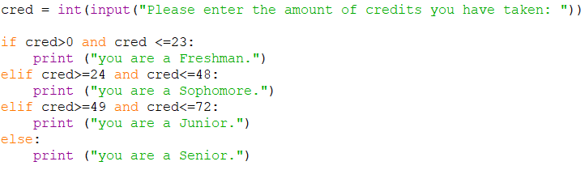
- Inputs and Outputs
  - Input – cred (int)
  - Output – class status
- Python Code (turned in as .py file)

